Interim Report
Group x500’s
mower023
leex8934
siew0053

Screen Captures
(Grabbing 0.jpg)
Server Output
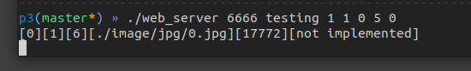
Wget Output
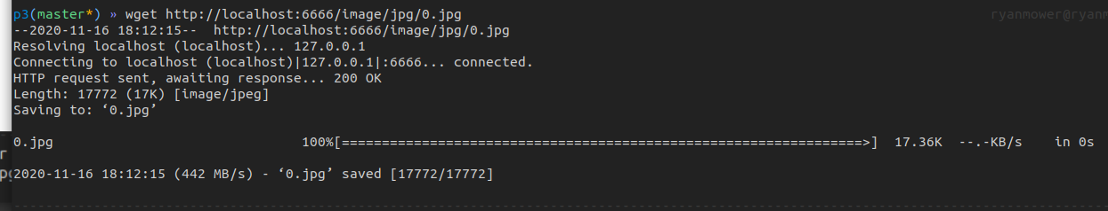

Plan for Work Distribution
Our group likes working synchronously because it allows us to bounce ideas off of each other and we are able to learn the entire project versus individual parts of the project. So we plan on working together for the rest of this project again. Working together includes finding times we are all free and coding together. We find this style most beneficial.

Plan for Extra Credit for A and B
Our plan for extra credit A and B first includes finishing the base project. Once the project is finished, we will start working on A and B.
For A, we are going to try to find a relation among the number of requests remaining in the queue every k (constant) amount of time and compare it to a previous ratio every k’ amount of time. From here, we would adjust the number a threads accordingly. This would be for the number of worker threads.

Extra credit B, we are thinking of making an array of requestsQueues. We will then iterate through the array, comparing if the current request’s file descriptor matches any within our array of requestQueues. If so, we would return the corresponding element of the array that pertains to that specific request.Queue. For the cache replacement policy, we plan on keeping an integer array that is one-to-one with our requestQueue array. The integers values correspond to the age of the elements inside the requestQueue array. Upon inserting a new element into the requestQueue array, we would insert at the index with the highest integer value in our one-to-one integer array. After inserting it, we would then set the new integer value to 0 and increment all the other integers. (This will simulate FIFO order in the cache.)

